Production Dashboard
- The below data it is just as assumption to make it like that it is not totally correct but ideas is similar like that only
*In this my project i want developed project dashboard where i want upload the excel/csv file and generate the detail analysis or graph like pareto chart ,pi chart ,bargraph,fishbone graph etc….
*if i update some data live then whole the graph and dashbord should also change while update any data .
*i want to department vise like(production ,quality,PPC(production planning control),SCM(suply chain management ,Store ,Maintenance,NPD (New product development),HR(Human resources),safety department and overall manufacturing analysis
*In the background i want transparent railway track system like this in below image
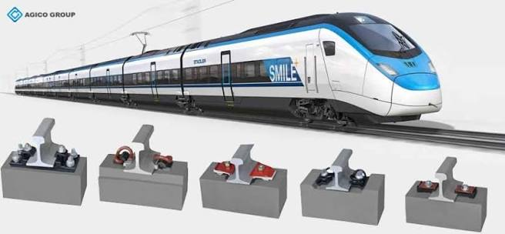
*generate the dashboard department vise and give the option upload and export of the data also and generate a google form of each department vise where user just fill the google form of each department vise get updated to in my department.
*Medchal_Downtime & Production department here some glimpses of column required in this not exactly it can vary also.
SL No | Date | Line | Shift | Part | Stage | Machine | Downtime Type | Downtime  Mints | Prod Loss  NOS | Prod Target  NOS | Total PROD  NOS | Rejection | Description | Month | week Nr | Heat No.
*the data which we uploaded ,the column and row or customised.

*each operator working in each machine he will uploade hourly production report add through google form for KPI(key performance indicator) generator.Same as other department follow also for KPI.
*each google form is link with each department should be generated and uploaded in google sheet in each department.
*Then uploaded data generate a dashboard /KPI or performance metrics of each department and overall analysis of all department and generate the conclusion.

*dash board it should something like this not exactly you can vary with my project 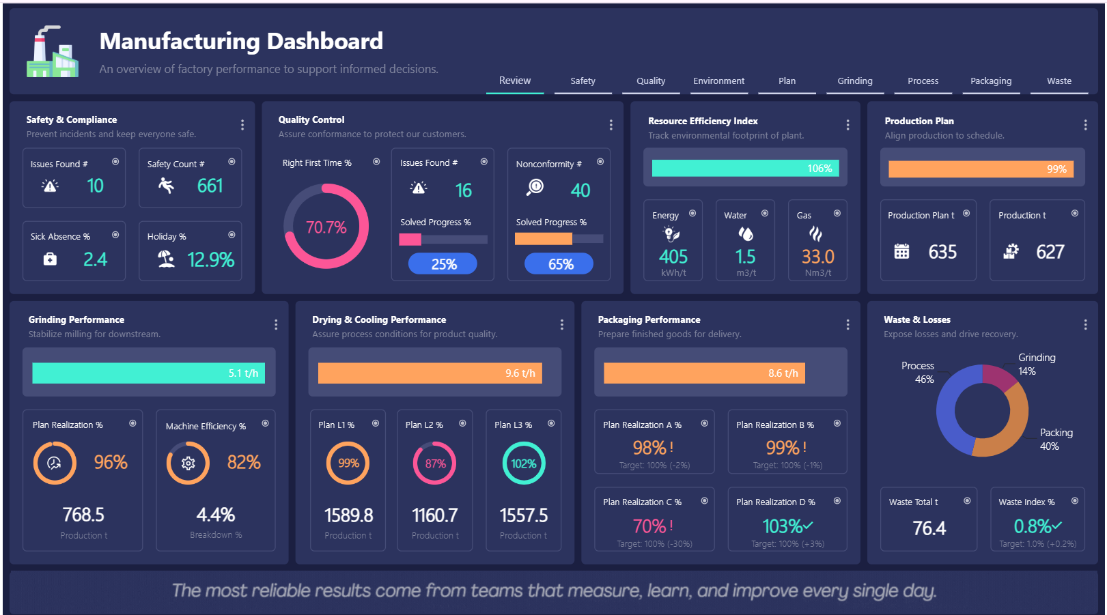
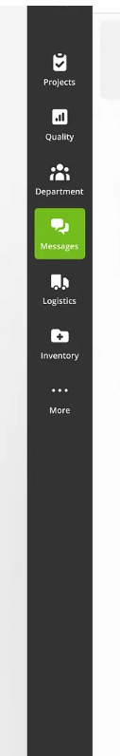

*Now i will tell department vise what we have to find if some thing i don’t know please add from your self
*plan, actual target ,line capacity
- Company Name - Patil Group & Logo

- Company Owner - Photo & Name - Dr. L.S. Patil (Lingaraj Shantalingappa Patil)

- 5S dashboard i want to make like this similar in below image
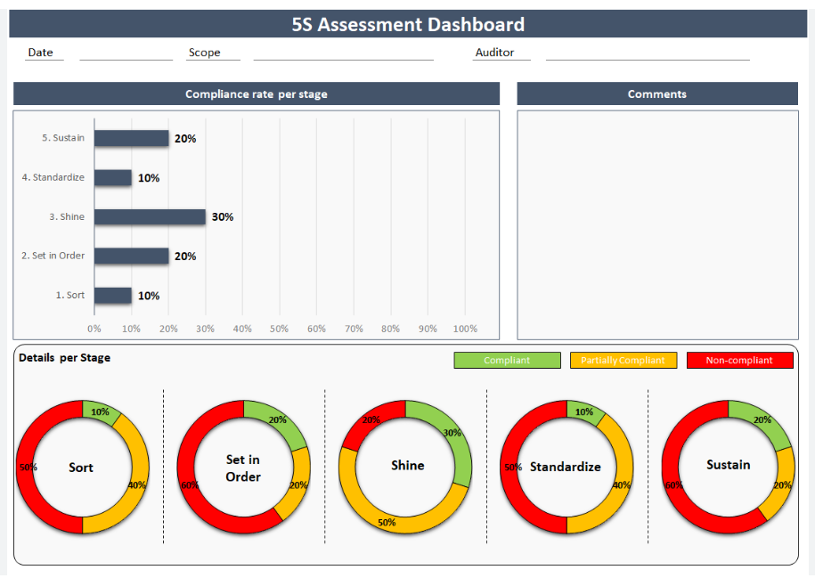
- Safety Rules

KPI's :- Key performance Indicators

Manufacturing :-

(i) OEE :- Overall Equipment Effectiveness
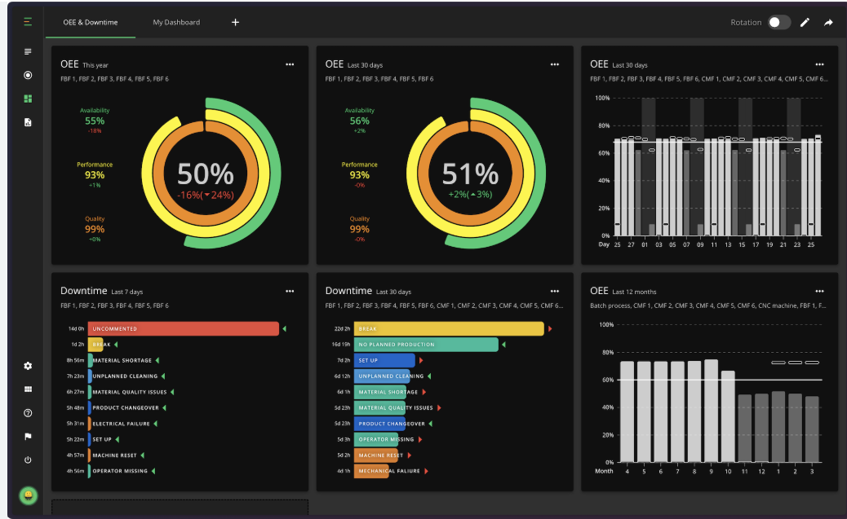

OEE(%) = Availability (%) * Performance (%) * Quality (%)

- Availability (%) = (Planned Production Time − Downtime) / Planned Production Time × 100
- Performance (%) = (Ideal Cycle Time × Total Produced Quantity) / Operating Time × 100
- Quality (%) = Good Quantity / Total Produced Quantity × 100

- Hourly Production Report (HPR)
- Daily Production Report (DPR) - OEE (calculate)

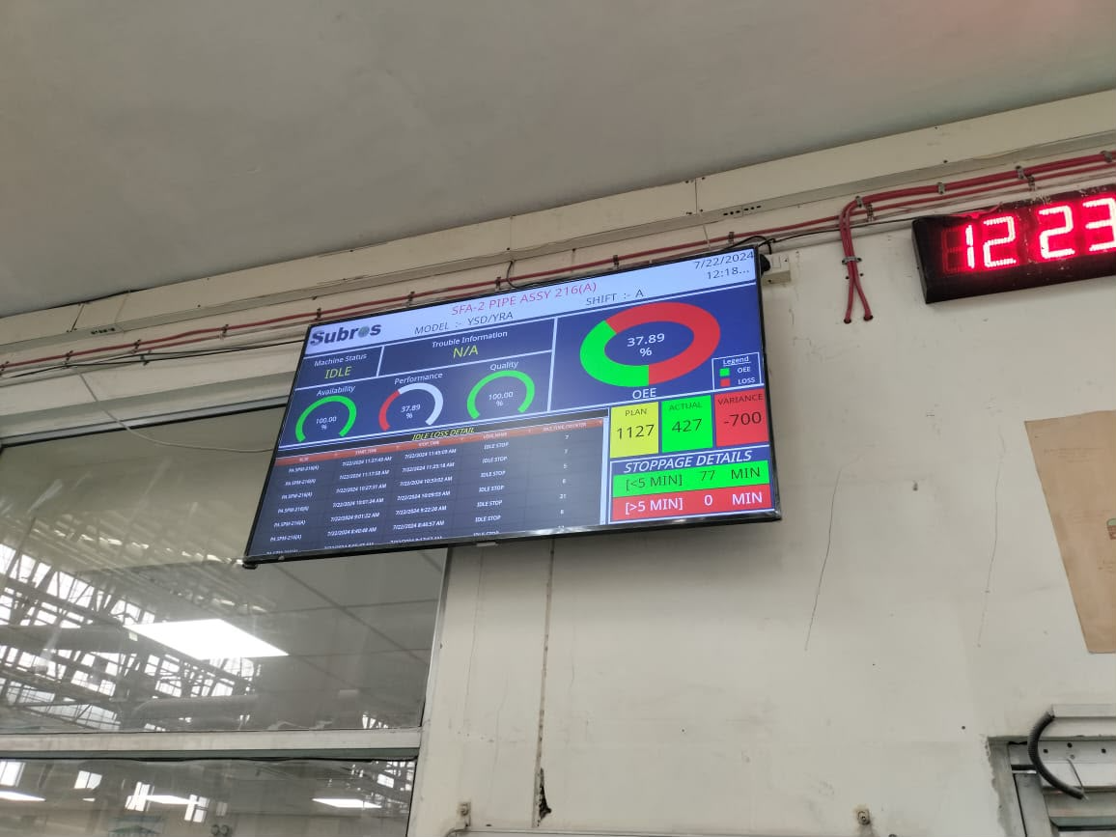

Production :-

- Production Achievement
- Machine Utilization (capacity)
- Rejection Rate
- Down time
- Plan vs. Target vs Actual

Quality :-

- Customer Complaints
- Internal Rejection
- CAPA closure
- Inspection Pass Rate
- Inprocess PPM
- Final PPM
- Customer PPM (Part Per Million)

Maintenance :-

- Preventive Maint. completion
- Breakdown frequency
- MTTR & MTBF

PPC :-

- Production Plan 'n' day ,'n+1' & 'n+2' days.
- Plan vs. Actual
- Material Availability
- On-time Production

Logistics / Dispatch :-

- GRN - Good Receive Note (Incoming Material Received )
- Delivery Accuracy =Plan Today Dispatch Status , FG Stock

HR :-

- Employee Attendance
- Attrition Rate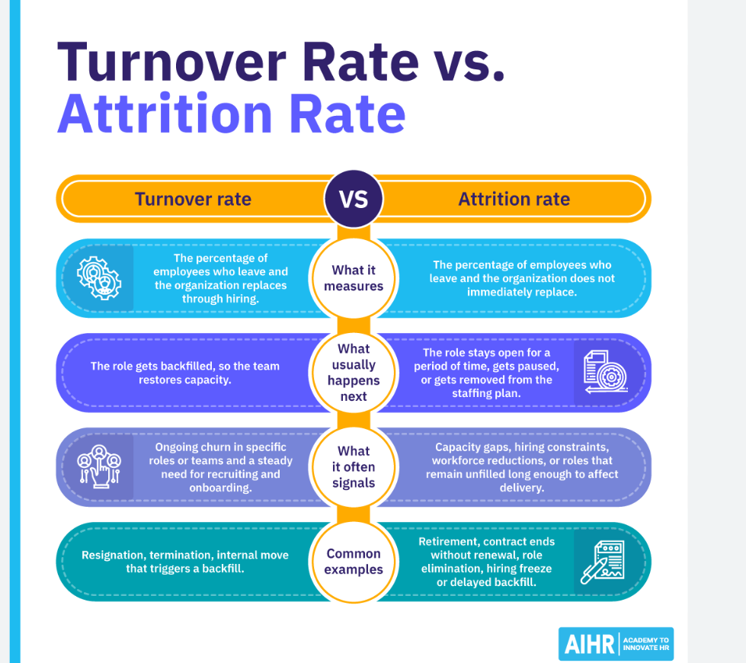
- Trainings Status

Safety :-

- Safety training completion
- Near Miss Reports
- Safety Audit score
- Lost time Injury (Status)

NPD / Design / R&D :-

- Drawing Release time
- Engineering change requests closed
- BOM Accuracy
- Design errors

Visuals / Reporting :-

- Pareto charts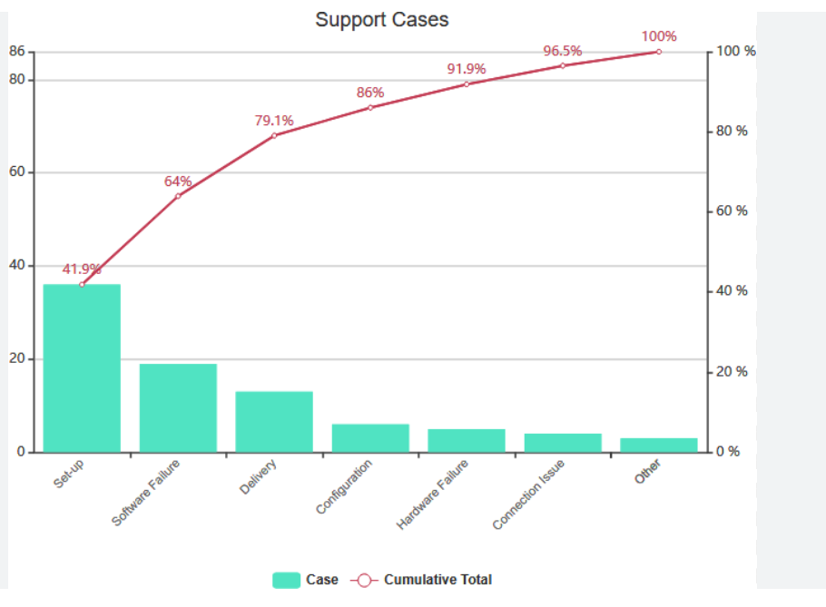
- Pie charts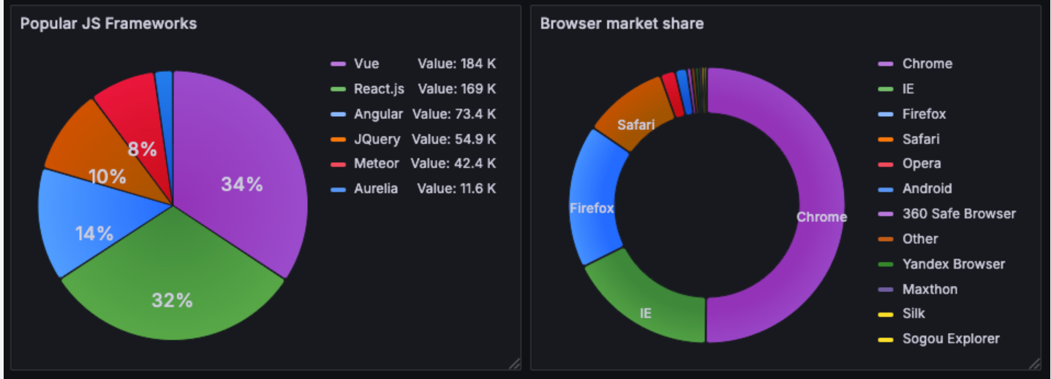
- KPI's score cards and make like this below with department vise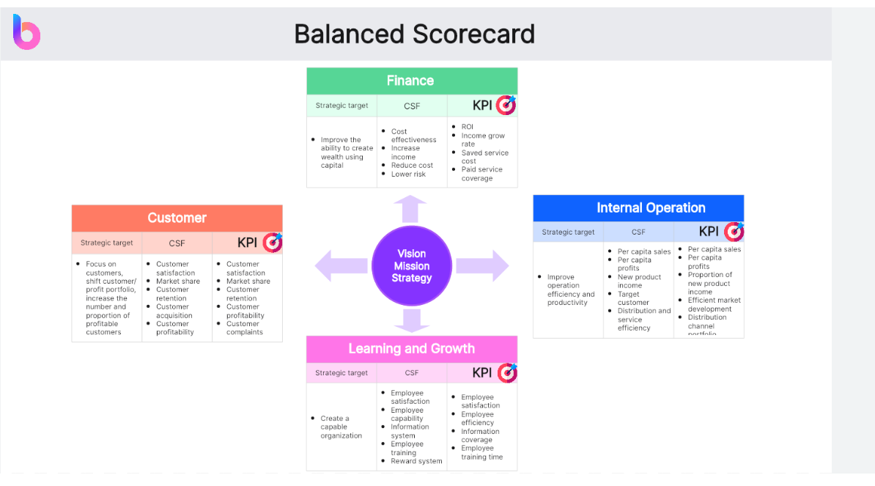
- Top 10 pending Actions

KPI Formula :-

- Overall KPI (%) = (Total Achieved KPI points /Total KPI target points)*100

